Create A Google My Business Profile

A company profile introduces a business's mission, goals, vision, and history. In most cases, a profile includes an 'About Us' section that narrates how the company was founded, its why's, and a section that introduces leadership team members.

- dentify a purpose for the profile. ...
- Select a style and format for the company profile. ...
- Incorporate contact information. ...
- Include the company's mission statement. ...
- Write about the company's history. ...
- Describe products and services. ...
- Include awards and recognition.
- Cover. Keep it simple, choose the best company image you can find. ...
- Basic Numbers. ...
- Mission and Vision. ...
- Team. ...
- Services. ...
- Clients. ...
- Projects. ...
- Quotes.
- Relevant skills and experiences.
- Relevant achievements and accomplishments.
- Years of experience.
- Strengths as a professional (both soft and hard skills)
- Signature traits related to the job.

EMPATHY MAP

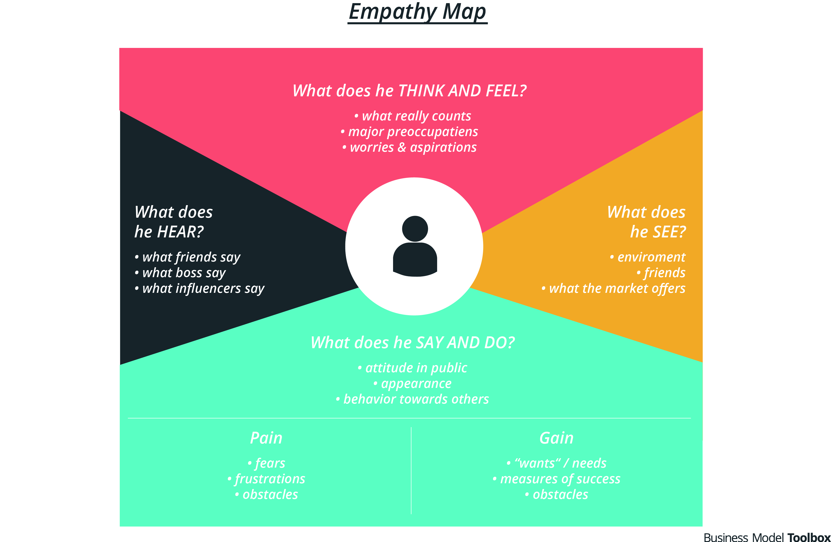

BRAIN STROMING

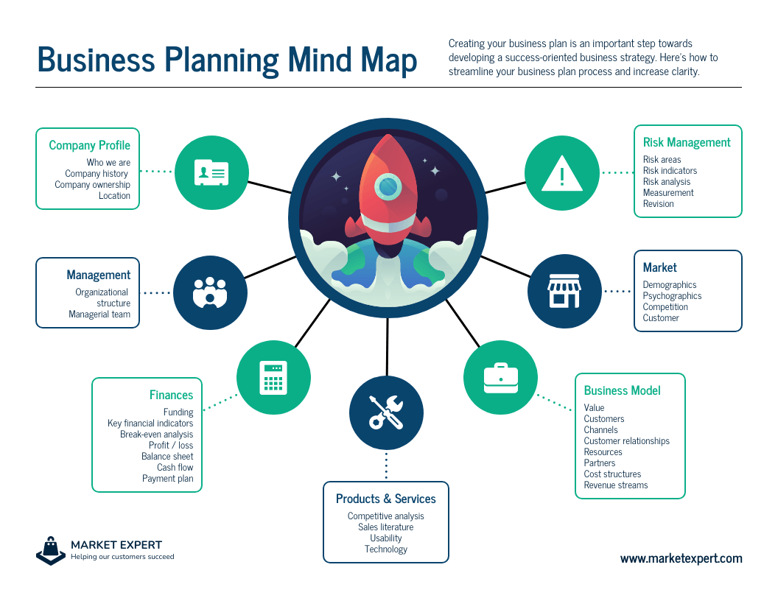

ADVANTAGES
A company profile is essential as it gives you a chance to tell your customers what your business is about; and what products and services you can offer. In other words, a company profile is a window to your company, giving business partners, customers, and employees a look at what you offer and provide.

